**Principal Investigator:** Professor Gaia Scerif

_

Anna Watts Building, Radcliffe Observatory Quarter, Oxford, OX2 6GG

Tel: 01865 271403, Email: [gaia.scerif@psy.ox.ac.uk](mailto:gaia.scerif@psy.ox.ac.uk); theone@psy.ox.ac.uk

**The ONE Programme**

Ethics Approval Reference: R85139/RE002

Dear Senior Leadership team,

I am writing to enquire about conducting some research in your preschool. We are a team of researchers from the University of Oxford and the University of Sheffield, led by Prof Gaia Scerif (Oxford) and Dr Emma Blakey (Sheffield) and funded by the Education Endowment Foundation as part of the Department for Education’s Early Years Recovery Programme. Our evaluation will be carried out by RAND and Qa Research.

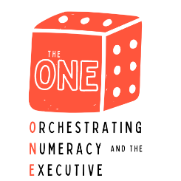Our programme, [the 'ONE'](https://theone.web.ox.ac.uk/) consists of practitioner development and guided play preschool activities to improve children’s numeracy and executive functions. Executive functions are a set of skills such as inhibiting actions and distractions, holding information in mind and thinking flexibly, that we now know are all essential to early years numeracy skills. The ONE aims to improve numeracy by combining executive and maths activities into a single intervention before entering school.

The research will take place with Early Years practitioners and children in the year before they enter Reception. We are looking for practitioners who are keen to learn more about early mathematics and executive functions, and introduce some fun new number activities into their teaching routines. We will not be making any judgements about their teaching styles or abilities. Our research focuses on children’s number knowledge and whether our intervention can improve executive and numeracy in preschool classrooms.

By participating in the research, your preschool would be contributing to research that will examine the benefits of developing executive function skills within the context of mathematics. We hope to improve numeracy by combining fun executive and maths activities into a single intervention. All our intervention activities are guided by research as well as important foundational milestones highlighted by the UK Department of Education’s Early Years Foundation Stage Framework.

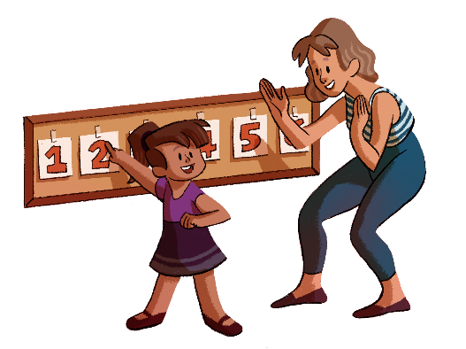The commitment from the preschool would be, firstly, to allow researchers from our evaluation team into preschool classes on two separate occasions: for a few days in autumn 2023, and again in summer 2024. They will collect data on children’s mathematics and executive function skills using a combination of tablet-based tasks, games using objects and movement-based games. We will also ask you to provide some information about the setting as a whole and about child characteristics. Practitioner data will be collected using questionnaires, interviews and classroom observations. Following this first set of assessments, all preschools will randomly be assigned either into an intervention group, who will receive the intervention in early 2024, or a waitlist group, who will receive the intervention during the academic year 2024-5.

The second main commitment would be to take part in the ONE programme intervention. The ONE consists of face-to-face training for educators, a pack of 25 activity cards, and resources to be used with the activities. The cards describe play-based maths activities that each last between 5 and 10 minutes, and integrate with everyday activities. Each setting is asked to engage in a minimum of three activities per week for the 12-week duration of the programme. During the first four weeks of the programme, staff will also be asked to attend weekly 30-minute face-to-face professional development sessions in their own settings. The sessions introduce the activity cards and support educators’ understanding of how early maths and executive functions co-develop.

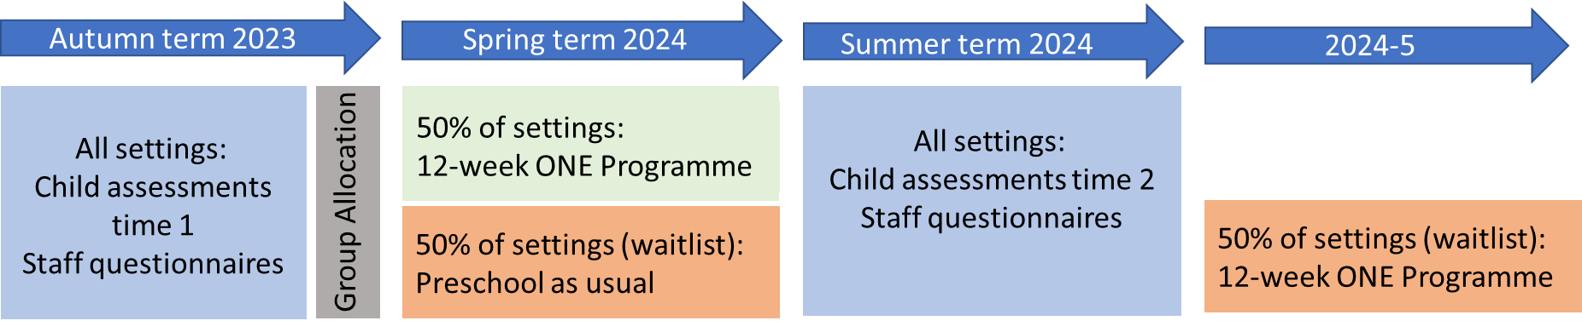

All groups will be provided parental information sheets and questionnaires for the participating children’s parents in addition to ‘opt-out forms’ to give them the chance to choose not to participate. Practitioners will be given the opportunity to ‘opt-in’ to taking part in the study and providing information about their experiences. If they do not wish to provide personal information, they will be given the opportunity to participate only in child specific elements of the study and not questionnaires about their own experiences, such as how they felt about the intervention or about their own prior teaching experiences.

The Universities of Oxford and Sheffield have strict ethical procedures on conducting ethical research with teachers and students, consistent with current British Educational Research Association guidelines. Before beginning the research, we would inform parents/guardians about the research and offer practitioners and parents/guardians the opportunity to refuse to participate. Throughout the research, children, practitioners and parents/guardians will be able to refuse to participate at any time.

All participants, including children, practitioners and preschools, would be made anonymous in all research reports.  The data collected would be kept strictly confidential and not used for any purpose other than specified without the further consent of all involved.  All our researchers and evaluators have an enhanced DBS check.

If your preschool would like to take part in the study, or you need more information about what is involved, please contact the ONE team ([theone@psy.ox.ac.uk)](mailto:theone@psy.ox.ac.uk)me) or fill out this [form](https://oxfordxpsy.az1.qualtrics.com/jfe/form/SV_5tGTSa6u9G2HRvo). Whether or not you feel it would be appropriate for your school to participate, I would be grateful if you would complete the pro-forma below and return it via e-mail or letter, at your preference.

Thank you for your time and attention.  The research team will contact you again shortly to answer any outstanding questions.

Yours Sincerely,   
Prof. Gaia Scerif and The ONE Team

|  |  |
| --- | --- |
| **The ONE Programme – Key dates and milestones:** | |
| **Parent information sheets sent out**  **(September 2023)** | * Information about the trial and opt-out forms shared with parents / carers |
| **Pre-Test**  **(Oct – Nov 2023)** | * Children complete short 30 mins assessments with independent assessors, Qa Research * Staff complete short questionnaires |
| **Group Allocation**  **(Dec 2023)** | * Schools are assigned to either the treatment or waitlist group |
| **The ONE programme**  **(Jan-May 2024)** | * TREATMENT GROUP ONLY (50% of settings) * Activities to be played with children for 12 weeks * Professional Development training for preschool staff during first 4 weeks |
| **Preschool as usual**  **(Jan – May 2024)** | * WAITLIST GROUP ONLY (50% of settings) * Preschool as usual |
| **Post-Test**  **(May – July 2024)** | * Children complete short 30 mins assessments with independent assessors, Qa Research * Staff complete short questionnaires and interviews |
| **The ONE programme**  **(Academic year 2024-5)** | * WAITLIST GROUP ONLY (50% of settings) * Activities to be played with children for 12 weeks * Professional Development training for preschool staff during first 4 weeks |

**STUDY TITLE:**

**The ONE Project**

[Preschool name]

[Preschool address]

[Manager / Head Teacher name]

We would like to find out more about this project.

We would like to take part in this project.

If you would like further information, or are interested in taking part, please give the name of a contact person for your preschool, and details of the best way to contact them.

Contact name:

Contact email:

Contact telephone number:

Please return this form in the stamped addressed envelope enclosed with this letter or via e-mail if preferred to [theone@psy.ox.ac.uk](mailto:theone@psy.ox.ac.uk). Thank you for your help.